8/7/2022

Assigned by: Sir Muzammil Shah Naqvi

Sukkur Iba university kandhkot campus

**Brick Breaker Game**

Project by: Sejal Seetlani, Dua Lashari

Table of Contents

**INTRODUCTION2**

**Why Play this Game?3**

Refresh your mind3

Reduce stress3

Develop creative thinking3

**How to play Brick Breaker Game?4**

**Project Details and technology5**

**Project Coding6**

List Project Library6

List of things that learned in this project7

**INTRODUCTION**

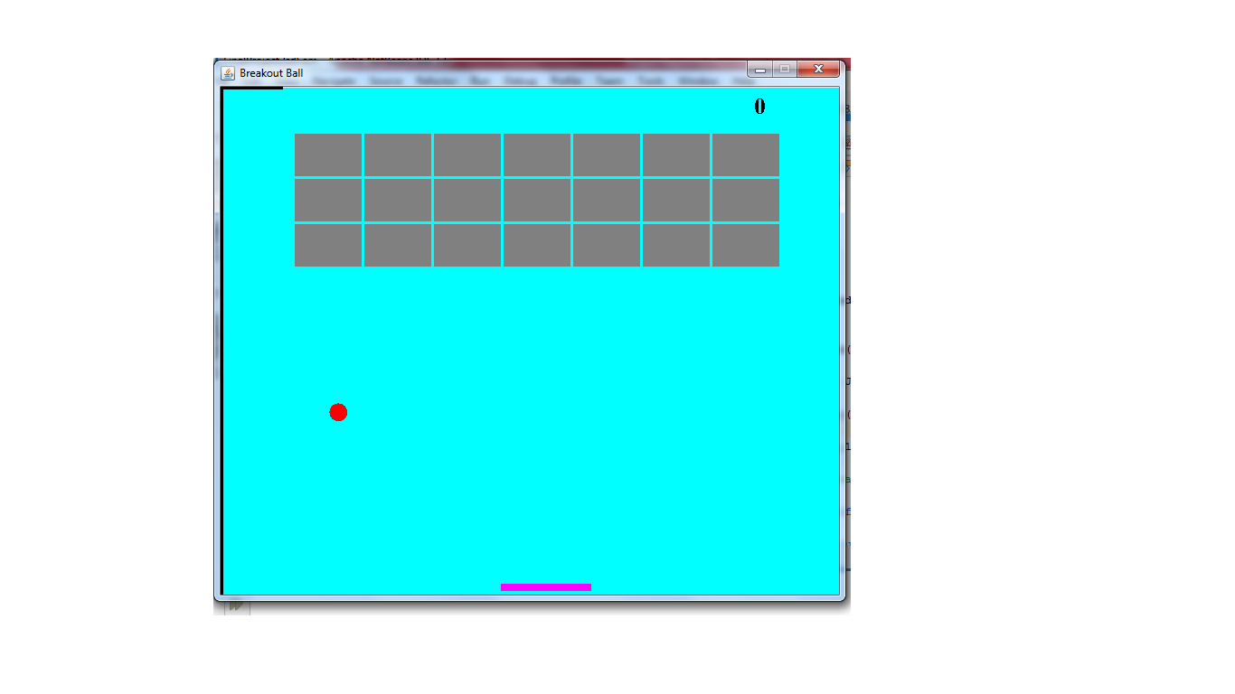The **Brick Breaker Game** is made up of Bricks, Paddle and Ball. Where bricks are target and player is represented by a ball. A little piece of board or platform at the bottom on the screen that support the ball not to drop down. The arrow keys help you to move that platform right to left. The objective of this game is to break as many bricks as possible without touching the ball with platform.

**Why Play This Game?**

**Refresh your mind~** in professional life we are working nonstop and this is not a good idea to work nonstop without relaxing your mind. Games help us to divert our mind from our tasks. The brain is able to refocus, refresh and taking a break can help you to be more productive at work.

**Reduce stress~** persons who are overworked always in stress. Game is a best source to reduce stress. Playing some **brick breaking game** you may find much needed relief from your daily grind.

**Develop creative thinking~** in these days we all are aware that games help us to think to make decisions by ourselves and after implementation of decision reached to result which shows whether decision was right or not. That’s how we learn and solve problem with our critical mind through games.

**How to play Brick Breaker Game?**

The **Brick Breaker Game** is easy to play. The main goal of this game is to break the bricks and make scores. The steps are below how to run the project:

**Step 1:** open project on Netbeans.

**Step 2:** *FinalProject2sdSem* is main class. Where run the project.

**Step 3:** Move arrow keys from keyboard.

**Step 4:** Press Enter to restart game (after lose or win match).

|  |  |
| --- | --- |
| **Project Details and Technology** |  |
| Project Name: | **Brick Breaker Game** |
| Abstract: | This **Brick Breaker Game** is simple developed in java for those who love to play unique games and also for IT or Computer science students to give them idea for a game project. |
| Language/s  Used: | Java swing |
| Java Version: | 13 |
| Developer: | Sejal Seetlani  Dua Lashari |

**Project Coding**

The Brick Breaker Game is built fully in Java. It has full featured Graphical User Interface (GUI) with all functionalities. This project is helpful for practicing java programming language. Its coding is fully logical and skillful that will give idea of coding for other projects.

**Project Libraries**

* import javax.swing.JFrame;
* import java.awt.Color;
* import java.awt.Font;
* import java.awt.Graphics;
* import java.awt.Graphics2D;
* import java.awt.Rectangle;
* import java.awt.event.ActionEvent;
* import java.awt.event.ActionListener;
* import java.awt.event.KeyEvent;
* import java.awt.event.KeyListener;
* import javax.swing.JPanel;
* import javax.swing.Timer;
* import java.awt.BasicStroke;

**List of things that learned in this project**

* How to access keyboard keys through KeyListener.
* Why use KeyPressed method.
* How to use Rectangle class in java.
* How to use Timer Library.
* Add more Styles of font.
* How to make project more attractive using Graphics and Graphics2D library.
* How to manage objects on screen and calculation of pixel on (x,y) axis.
* How to set the location of rectangle and manage pixels.
* g.fillRect(x, y, WIDTH, HEIGHT);
* How to use .intersects() function.
* How to use design.java class methods or attributes in play.java Class without extends keyword.

**THANK YOU**